Group : G4
Contributors
1. Mr. Thananop Kullapan 653-01821-21
2. Mr. Kanawat Suwandee 687-00268-21
3. Mrs. Yuwadee Tongkong 687-20736-21

Download the Google sheet and answer all the questions. Please download as a PDF file and rename it from `Lab4.pdf` to `Lab4_G1.pdf`.

Your tasks are:
Go to Github Lab4 and Google Doc

Goal:
- can implement SVM and train the model.
- can use the evaluation metrics and validation techniques to choose the best model configuration for SVM.

We have implemented the code in Github Lab4 to support your experiment in main.ipynb.

Your tasks are …
- Explain how you set up the experiment, e.g.,
  - How you split the data for training, validation, and testing.
  - Find out the default hyperparameter setting for each kernels,
  - Declare which assessment metric that you use to check SVM’s performance (e.g., F1-score, accuracy, ROC curve).
You can do this by using a diagram or flowchart to help explain.

- Finding the suitable kernel. Show how the learned model has changed with different kernels:
  - Linear kernel (‘linear’)
  - Polynomial (‘poly’)
  - Radial basis function (‘rbf’)

- Find the most suitable kernels based on the performance on the validation dataset.
  - The plot of the SVM performance curves versus different kernels. You need to use the validation dataset to verify SVM performance.
  - Show the scatter of validation data points against the decision contours across different kernels. Note that you should use the training data for showing the decision contours.
  - Explain which decision contour that you would choose to fine-tuning the results.

- Fine-tuning phase.
You have to implement your own python script to perform fine-tuning.

  - Explain how you set up the experiment for fine-tuning.
    - Declare how you will adjust the hyperparameter setting for the chosen kernels.
    - Declare how you will verify if the fine-tuning performance is getting better.
  - The plot of the SVM performance curves versus different hyperparameter settings. You need to use the validation dataset to verify SVM performance.
  - Explain which hyperparameter setting is the best for the chosen kernels.
  - Verify if the final setting gives the best performance on testing data.

Make sure that every point that you made is supported by the evidence and the data.

Question 1: Set up the experiment
Explain how you set up the experiment, e.g.,
1. How you split the data for training, validation, and testing.
2. Find out the default hyperparameter setting for each kernels,
3. Declare which assessment metric that you use to check SVM’s performance (e.g., F1-score, accuracy, ROC curve).
You can do this by using a diagram or flowchart to help explain.
Answer
1. Data Splitting: The experiment's dataset was partitioned into three distinct subsets using a custom split function to ensure a robust evaluation of the model. Specifically, the data was divided into an 80% Training dataset (1,600 samples) used to teach the model, a 10% Validation dataset (200 samples) used to tune hyperparameters and compare different kernels without bias, and a 10% Testing dataset (200 samples) strictly held out to evaluate the final model's performance on unseen data.
2. Default Hyperparameter Settings: When initializing the Support Vector Classifier (SVC) in the experiment without explicitly defining parameters, the model utilizes the default settings provided by the scikit-learn library. Across all kernels, the default regularization parameter is set to C = 1.0. For both the 'rbf' and 'poly' kernels, the kernel coefficient defaults to gamma = 'scale', and specifically for the polynomial kernel, the default function flexibility is set to degree = 3.
3. Assessment Metric: The primary assessment metric utilized to evaluate and verify the SVM's performance across the different kernels in this notebook is the Confusion Matrix. This matrix provides a detailed, structured breakdown of correct and incorrect classifications (true/false positives and negatives). From this matrix, the overall Accuracy score is derived and used as the definitive metric to compare model effectiveness during the validation and fine-tuning phases.

Question 2: Finding the suitable kernel
Finding the suitable kernel. Show how the learned model has changed with different kernels:
  - Linear kernel (‘linear’)
  - Polynomial (‘poly’)
  - Radial basis function (‘rbf’)
Answer
The notebook trains three different models and evaluates them on the validation data. The learned models changed their decision boundaries based on the kernel used, which resulted in the following Confusion Matrices
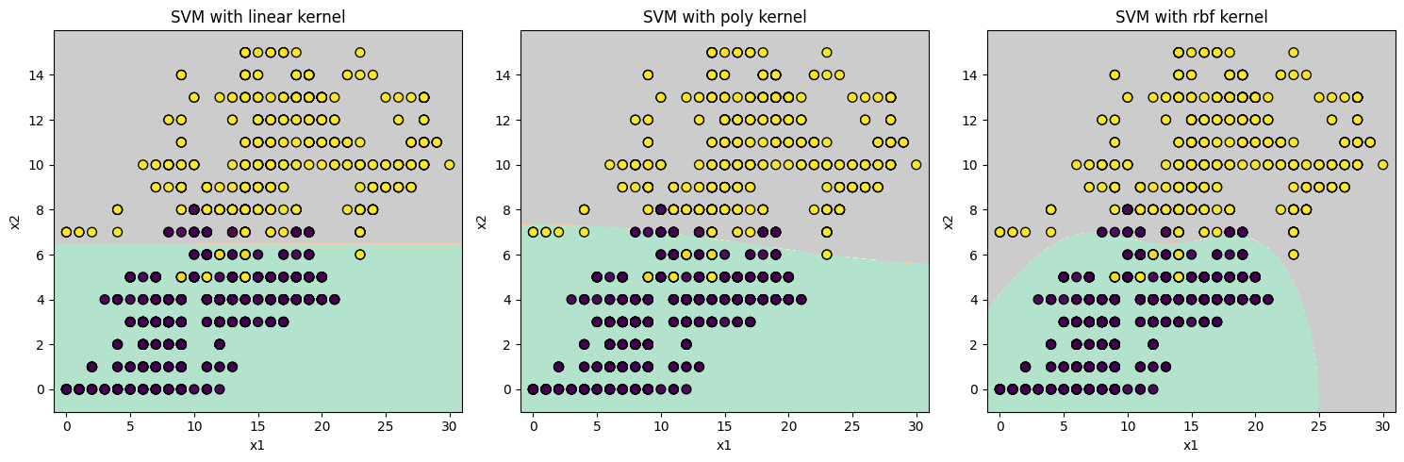
from sklearn.metrics import confusion_matrix
X_valid = valid_df[feat_column].values
y_valid = valid_df[target_column].values.reshape(-1)
clf_list = [clf_linear, clf_poly, clf_rbf]
clf_name_list = ['linear', 'poly', 'rbf']
for clf, name in zip(clf_list, clf_name_list):
y_pred = clf.predict(X_valid)
print("Confusion Matrix for %s kernel:" % name)
print(confusion_matrix(y_valid, y_pred))
print()

- Linear kernel ('linear'): Creates a straight-line decision boundary.
  - Result: [[91, 6], [6, 97]] (12 misclassifications)
- Polynomial kernel ('poly'): Creates a curved decision boundary.
  - Result: [[95, 2], [6, 97]] (8 misclassifications)
- Radial basis function ('rbf'): Creates non-linear, localized contour boundaries.
  - Result: [[91, 6], [6, 97]] (12 misclassifications)

Question 3: The most suitable kernels based on the performance
Find the most suitable kernels based on the performance on the validation dataset.
- The plot of the SVM performance curves versus different kernels. You need to use the validation dataset to verify SVM performance.
- Show the scatter of validation data points against the decision contours across different kernels. Note that you should use the training data for showing the decision contours.
- Explain which decision contour that you would choose to fine-tuning the results.
Answer
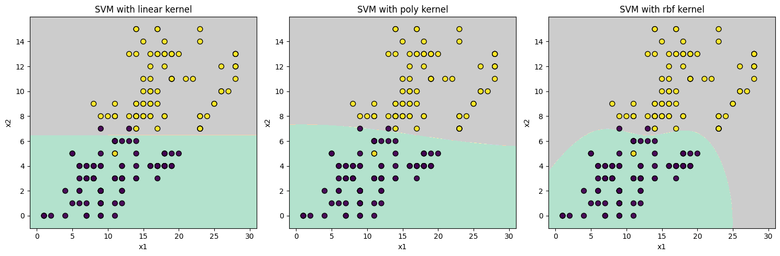
- Based on the validation dataset, the Polynomial ('poly') kernel is the most suitable because it yielded the fewest misclassifications (only 8 errors compared to 12 errors in both linear and RBF kernels). We would choose the Polynomial ('poly') decision contour for fine-tuning. The base polynomial curve already fits the data distribution better than a strict linear line, but fine-tuning its hyperparameters could further reduce the remaining validation errors.

Question 4: Fine-tunning Phase
- Explain how you set up the experiment for fine-tuning.
- Declare how you will adjust the hyperparameter setting for the chosen kernels.
- Declare how you will verify if the fine-tuning performance is getting better.
- The plot of the SVM performance curves versus different hyperparameter settings. You need to use the validation dataset to verify SVM performance.
- Explain which hyperparameter setting is the best for the chosen kernels.
Verify if the final setting gives the best performance on testing data.
Answer
To fine-tune the model, we systematically adjust the hyperparameters for the chosen 'poly' kernel and verify the performance against the validation dataset before finalizing it on the testing data.
1. Experiment Setup and Adjustments: We set up the fine-tuning experiment using a Grid Search approach to test the interactions between two main hyperparameters of the polynomial kernel. First, we adjust the regularization parameter C using a range of values [0.1, 1, 10, 100] to balance the trade-off between having a smooth decision boundary and correctly classifying the training points. Simultaneously, we adjust the degree parameter using values [2, 3, 4, 5, 6, 8, 10] to control the flexibility and curvature of the decision boundary.
2. Verification of Fine-tuning Performance: To verify if the fine-tuning performance is improving, we use Validation Accuracy as our primary evaluation metric. By predicting the target values on the validation dataset for every combination of C and degree, we can objectively compare the scores and identify which parameter pair yields the highest predictive accuracy.
3. The Plot of SVM Performance Curves: Based on the generated performance plots, we utilize two main visualizations to analyze the results. The Heatmap provides a clear grid view, visually highlighting the specific parameter combinations that achieve the highest validation accuracy. Moreover, the Interaction Plot (Trend Graph) illustrates the behavior of each polynomial degree as C increases (plotted on a logarithmic scale). For instance, it shows that a model with degree=4 reaches its peak performance early at C=1. In contrast, highly complex models like degree=5 demonstrate a tendency to overfit, causing their validation accuracy to decline steadily as the C penalty increases.

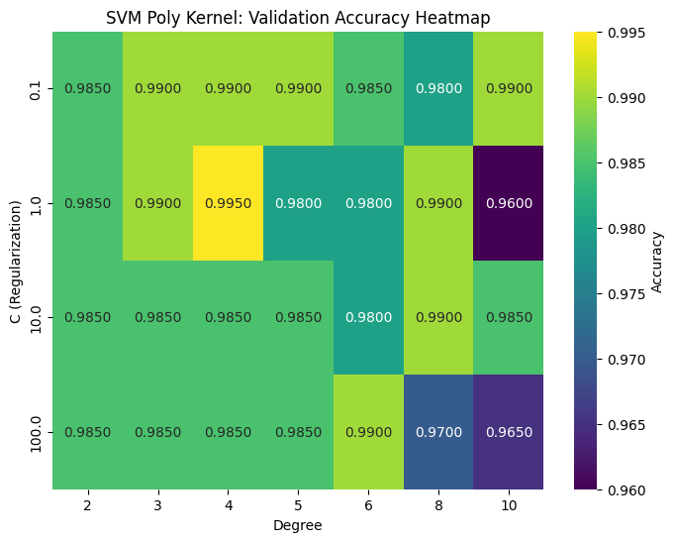
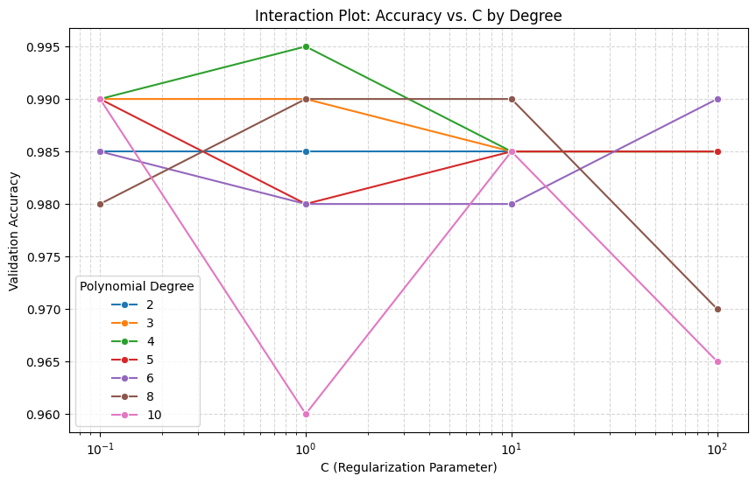
4. The Best Hyperparameter Setting: Based on the validation performance curves, the best hyperparameter setting for the chosen polynomial kernel is C = 1 and degree = 4, which achieves the highest validation accuracy of 0.9600.
5. Verification on Testing Data: Finally, we verify this chosen setting by training the final model with C=1 and degree=4 and evaluating it on the unseen testing dataset. The model achieves a Final Testing Accuracy of 0.9950. Because this testing score is highly consistent with the validation score (0.9600), it confirms that the fine-tuning phase was successful, demonstrating that the model generalizes well without suffering from overfitting.

Python Code
from sklearn.metrics import accuracy_score
import pandas as pd
import matplotlib.pyplot as plt
import seaborn as sns
# 1. Define hyperparameter grid for the Poly kernel
C_values = [0.1, 1, 10, 100]
degree_values = [2, 3, 4, 5, 6, 8, 10]
best_acc = 0
best_C = None
best_degree = None
# Create a list to store all results
all_results = []
# 2. Loop through combinations
for C in C_values:
for degree in degree_values:
clf_tune = svm.SVC(kernel='poly', C=C, degree=degree)
clf_tune.fit(X_train, y_train)
y_valid_pred = clf_tune.predict(X_valid)
acc = accuracy_score(y_valid, y_valid_pred)
# Save the current combination's score
all_results.append({'C': C, 'Degree': degree, 'Accuracy': acc})
if acc > best_acc:
best_acc = acc
best_C = C
best_degree = degree
# Convert results to a DataFrame for easy plotting
results_df = pd.DataFrame(all_results)
results_df.head()
results_df.to_csv('results.csv', index=False)

